Bandit level 11 to level 12
To login to the level 11 use the username as
Use ls command to list the files.
Use cat <filename> command to display the contents of the file.
And then use tr 'A-Za-z' 'N-ZA-Mn-za-m' < data.txt command to shift each letter by 13 positions to decode the text.
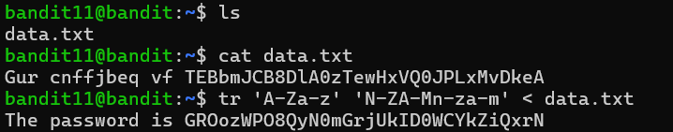
And finally we will get the password for the level 12.

